**Project proposal**

**Project title**: Skill Improver.

**Introduction:** Skill improver is a problem solving platform. This platform will be an android application. To improve a person there is no alternative to building confidence through solving problems. The main goal of this application is to helping people to improve through solving problems on mind-storming topics. Also anyone can acquainted with his own levels through standings and according to that he/she can improve his/her skill.

**Description:** As there will be containing the track of the users; so firstly there will be options for sign up and login. After that there will be category-wise problems. Users can submit answers for corresponding problems and get verdict according to the submission. If anyone able to solve problems he/she will get points. There will be resources for learning different topics. Finally there will be standings of the users.

Sign up Log in

Problemset(levelwise)

Standings

Resources

Fig: UML Design

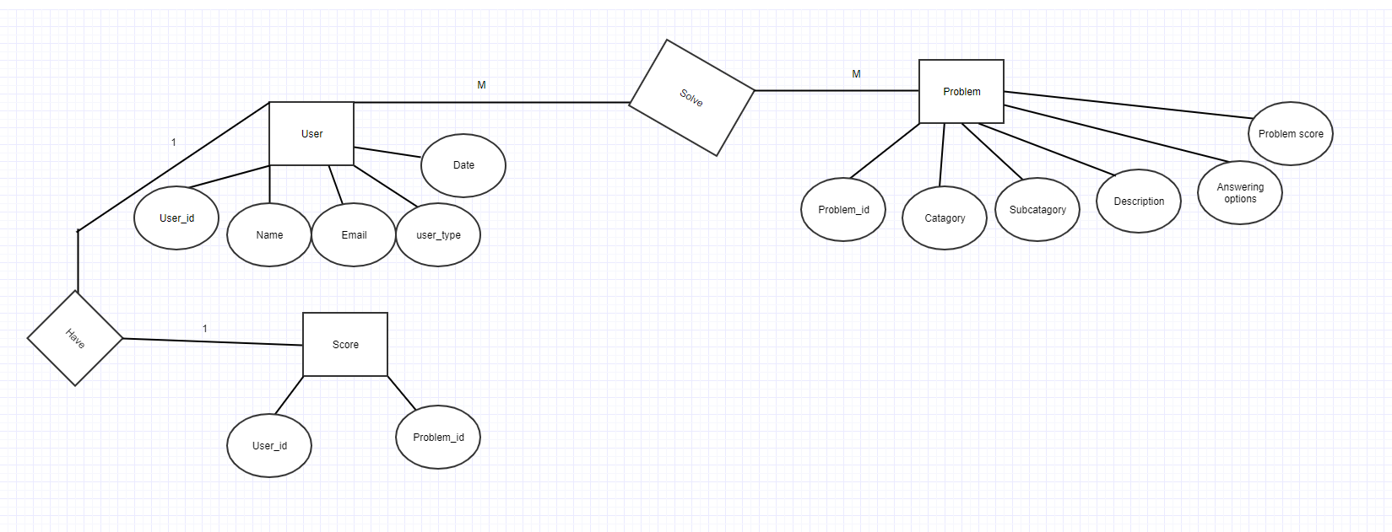

Fig:ER-Diagram

Conclusion: I believe that this application will give the users an easier platform for practicing problems and improve the confidence.